S11_2420030250_ExperimentNo 2_Case Study 2
Experiment 2: Case Study
Problem Statement: Identify an appropriate case study and select a suitable process model and programming language for its implementation and evaluation.
1. Functional Requirements
Customer
- Register and login
- Audio Recording
- Real-Time Transcription
- Select a preferred language or auto-detect
- Convert speech to text
- Search previous transcription
- Switch between dark and light mode
- View transcription result instantly
Admin
- Manage Groq API configuration
- Manage mongodb database connection
- Maintain transcription records
- Monitor storage capacity
- Ensure backend security and data integrity

2. User Stories
User ID | User Story | Priority
US-01 | As a user, I want to record my voice using the microphone so that I can convert speech into text. | High 8
US-02 | As a user, I want to choose my preferred language before recording. | High 8
US-03 | As a user, I want the system to detect my language automatically. | Medium 6
US-04 | As a user, I want to receive real-time speech transcription. | High 7
US-05 | As a user, I want to view all previous transcriptions. | Medium 6
US-06 | As a user, I want to search my transcription history | Medium 6
US-07 | As a customer, I want to pay online securely. | Medium 6
US-08 |  | Medium 5
  As a user, I want to filter transcription history by language.
US-09 | As a user, I want to delete unwanted transcription records. | High
US-10 | As an admin, I want API keys to remain secure on the backend. | High
US-11 | As an admin, I want to monitor API usage and database performance. | Medium
3. Selected Software Development Process Model
Agile Scrum
Reason for Selection
- Requirements change frequently.
- Supports rapid development
- Allows continuous feedback
- Flexible for adding future features

Sprint Plan
Sprint | Features
Sprint 1 | User Registration & Login
Sprint 2 | Record voice and speak
Sprint 3 | Convert speech -to - text
Sprint 4 | Can see transcription history
Sprint 5 | Admin Dashboard
Sprint 6 | Testing & Deployment

4. Programming Language Selection
Backend
- Java Script(Node.js)
- Express .js
Reasons
- Secure
- Fast and scalable
- Easy REST API support
- Excellent database connectivity
- Efficient asynchronous processing

Frontend
- HTML5
- CSS3
- JavaScript
- React.js
- Tailwind css

Database
- Mongodb
Other Technologies
- REST API
- JWT Authentication
- Groq whisper API
- Git
- versel

5. System Architecture
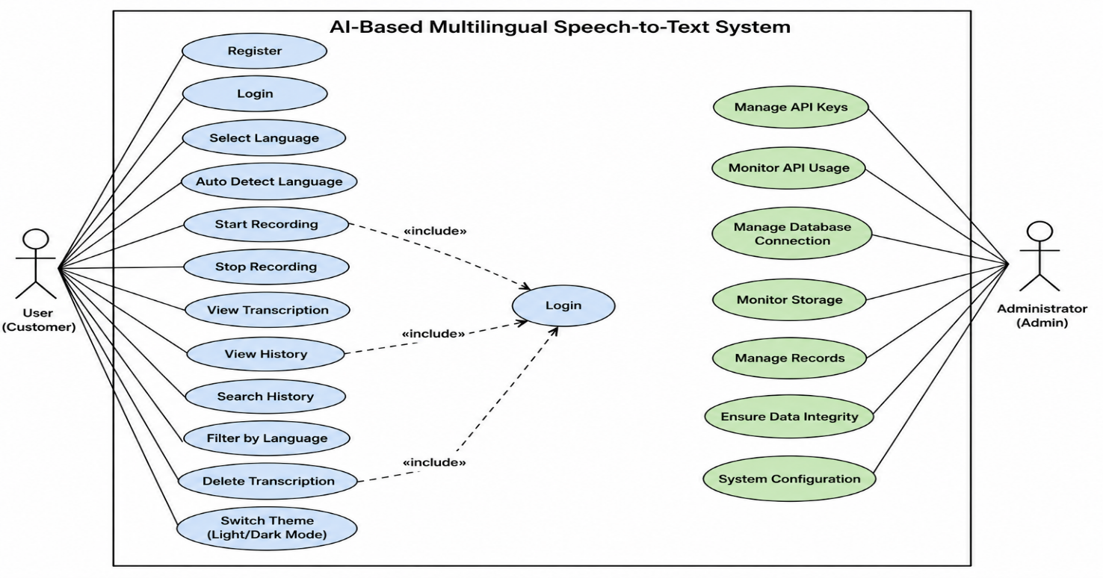

6. Implementation Strategy
Phase 1 – Requirement Analysis
- Gather customer requirements.
- Create Software Requirement Specification (SRS).
- Design use case diagrams.

Phase 2 – System Design
- Design MongoDB schema.
- Create UI wireframes.
- Design system architecture.
- Define REST APIs..
Phase 3 – Development
- Implement user authentication.
- Implement audio recording.
- Integrate Groq Whisper API.
- Develop transcription history.
- Implement search and filter functionality.
- Add delete operations.
- Implement Dark/Light mode..
Phase 4 – Testing
Unit Testing
- Login
- Registration
- Audio recording
- Language selection
- Theme switching

Integration Testing
- Frontend + Backend
- Backend + Groq API
- Backend + MongoDB
System Testing
- Complete application testing
User Acceptance Testing (UAT)
- Verify transcription accuracy.
- Verify UI functionality.
- Verify language support..

Phase 5 – Deployment
- Frontend using Vercel.
- Backend using Render.
- MongoDB Atlas database.
- Environment configuration using .env.

7. Evaluation Strategy

Evaluation Parameter | Method
Functional Accuracy | Requirement verification
Performance | Response time and latency testing
Security | Authentication and API key protection , backend validation
Reliability | Continuous monitoring
Usability | User feedback survey
compatability
  Cross-browser testing
Maintainability | Code review and documentation

10. Expected Outcomes

- Fast multilingual speech-to-text conversion.
- Accurate real-time transcription.
- Secure backend architecture.
- Dark and Light mode support.
- High-performance AI-powered speech recognition.
- Responsive and modern user interface.

Name:- SAMHITH ALAVALA
Roll no:-2420030250
Sec:-11

